Year 8 Chemistry Test 1 – Atoms, Elements and the Periodic Table

____ / 24

 | The word ‘atom’ comes from the Greek word:  - atoma, meaning ‘that which cannot be seen’.  - atomis, meaning ‘imaginary particle’.  - atomos, meaning ‘that which cannot be divided’.  - atome, meaning ‘small sphere’. | C | 1
 | An element is a substance that:  - is made of atoms.  - cannot be broken down into other substances.  - contains water.  - is a metal used in kettles. | B | 1
 | The lightest element is:  - helium.  - hydrogen.  - lithium.  - carbon. | B | 1
 | The component of an atom that is positively charged is the:  - proton.  - electron.  - neutron.  - electron shell. | A | 1
 | Most of an atom is taken up by:  - the nucleus.  - charged particles.  - empty space.  - moving particles. | C | 1
 | The mass number is:  - the number of protons in the nucleus.  - the number of protons and neutrons in the nucleus.  - the number of protons and electrons in the nucleus.  - the number of neutrons and electrons in the atom. | B | 1
 | Draw and label a diagram showing the various parts of an atom containing five protons and five neutrons. Label the nucleus.  Name which element this is an atom of. | 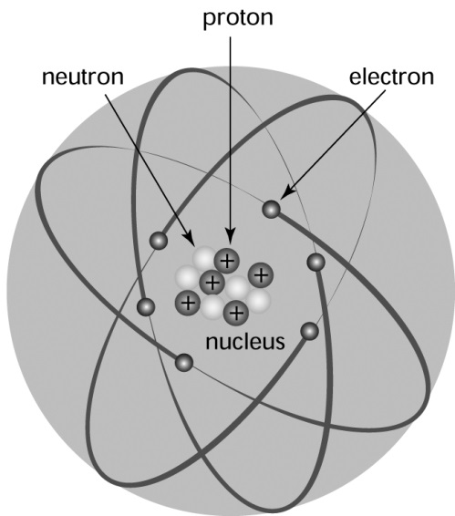  Drawn five protons and five neutrons and distinguished them from one another – 1  They are in the centre of the atom – 1  This is labelled as the nucleus – 1  Electrons are shown around the outside (should be about 5, not too many more or less) – 1  Atom is identified as Boron - 1 | 5
 | Give the symbols for the following elements.  - Hydrogen  - Lithium  - Boron  - Nitrogen  - Fluorine  - Potassium  - Sodium  - Chlorine | - H  - Li  - B  - N  - F  - K  - Na  - Cl  Take off ½ mark if capital/lowercase is incorrect | 8
 | Identify the contribution Democritus made to science. | He proposed that all matter was made of atoms. | 1
 | When electricity is passed through water, it splits the water (H₂O) into hydrogen and oxygen. How much hydrogen is there, compared with oxygen? | There is twice as much hydrogen as oxygen. | 1
 | For each element shown below, the atomic number and mass number are shown. Use this information to identify the number of neutrons usually found in the nucleus of these atoms:  (a) zinc  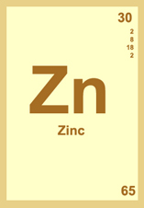  (b) gold  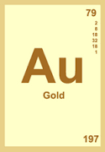  (c) scandium.  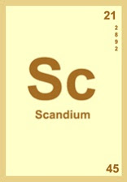 | (a) 65 – 30 = 25  (b) 197 – 79 = 118  (c) 45 – 21 = 24 | 3

